***Overview***

The goal of this work was to assess the determinants of population growth (aka, declines..) in southern mountain caribou. Specifically, we were looking to characterize the influence of human-caused habitat disturbance, and climate change on southern mountain caribou population growth rates between 1984-2021. We sought estimate, if possible, levels at which influential variables likely precipitate population declines. We did not assess the specific role of because it was is generally rare compared to other disturbances (unlike in the boreal).

There is expansive literature linking disturbance-mediated apparent competition (human-caused habitat disturbance->prey->wolves->declining caribou) to population declines in boreal and southern mountain caribou. We thus expected strong, and repeatable relationships between disturbance and caribou population declines within and across herds. We were cautious of interruptions to this mechanism such as human-caused manipulations in predator or prey densities through culls or introductions that would decouple disturbance from the proposed mechanism of decline–disturbance-mediated apparent competition. We explored multiple time lags because disturbance may not immediately impact populations, as well as alternate hypotheses such as climate-mediated apparent competition.

**Methods**

Caribou demographic data was collected from provinces and contractors. Annualized disturbance data for each herd was provided by ECCC. We used a combination of fire, logging, and mining disturbances to characterize disturbance. Disturbance measures excluding fire correlated to the measures with fire at r=0.994 suggesting including/excluding fire would not have a meaningful impact on results, unlike in the boreal. We assessed the time stamped road data provided by BC/ECCC but decided not to use it due to poor validation when overlayed with satellite imagery, and data inconsistencies such as chunks of the same road with different year, etc. Annual climate variables for each herd were gathered from daymet, and consisted of temperature (min, max, and range), precipitation, snow water equivalent, vapour pressure, solar radiation, day length. We fit a PCA to these climate variables to create synthetic and simplified climate measures. Two PCA variables (clim1 and clim2) explained 90% of the variation from the 8 climate variables. Clim1 represented lower minimum temperatures, larger ranges of temperature variation, and lower vapor pressure, Clim2 represented areas with high precipitation and snow, short days, and low temperatures.

Throughout the methods and result we will refer to analyses “within” or “across” herds. These are noteworthy and are different. Analyses looking within a herd asks how climate and disturbance changes through time correspond to changes in each herds’ demography. Across herds considers how climate and disturbance differences between herds corelate. In math terms this means the within herds analysis used a random intercept for herd (why are herds changing through time?), and the across herd models used a random intercept for year (why is density different between herds?).

*Figure 1. PCA diagram showing how the climate variables align along the two climate axes (clim1=Dim1, clim2=Dim2). Prcp=precipitation, swe=snow-water equivalent, srad=solar radiation, range=max-min temperature, dayl=day length, tmax=max temp, tmin=min temp, vp=vapour pressure. All climate variables were summarized annually at the herd level.*

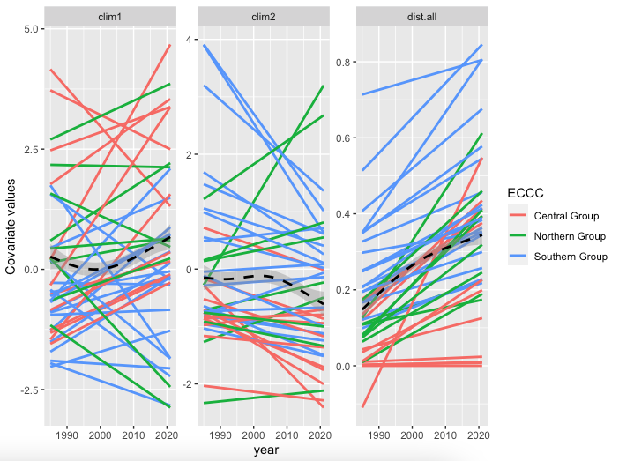

*Figure 2. Annual changes in climate and disturbance variables through time. Each herd is shown as a line from a linear model for each herd. Colors pertains to the population group. An overall population average is shown as the dotted line.*

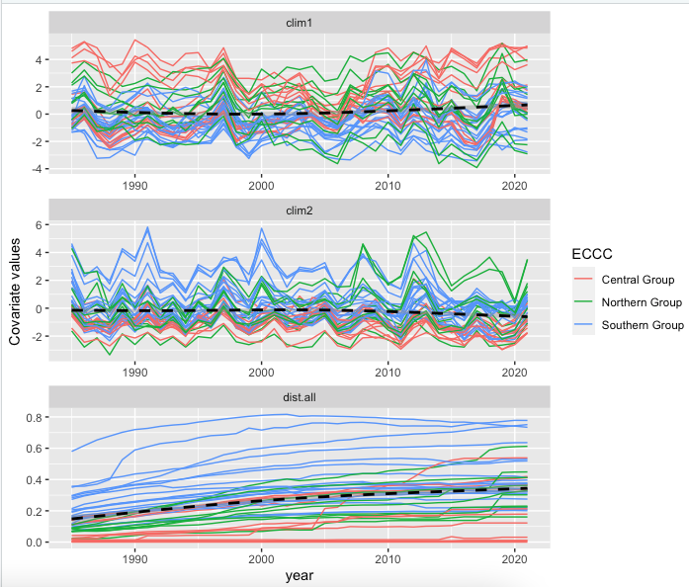

*Figure 3. Annual changes in climate and disturbance variables through time. Each herd is shown as a colored line which pertains to their group. No data smoothing or modelling is done here, each herd is shown with their raw annual data. An overall population average is shown as the dotted line.*

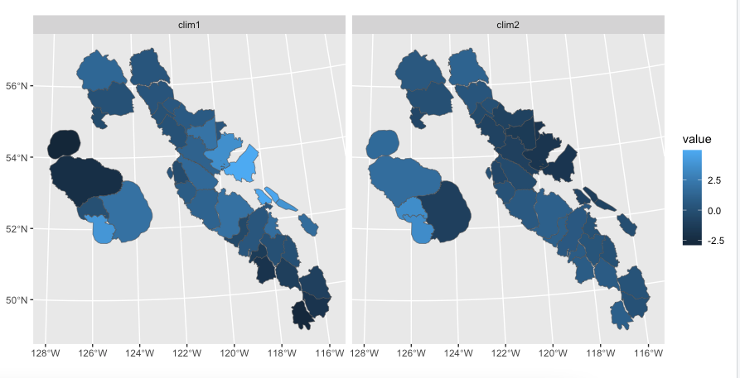

*Figure 3.2. Map showing the spatial distribution of covariate values as of 2021.*

***Necessary conditions***

We can estimate caribou population growth with reasonable precision. Climate and disturbance variables are correlated at r<0.6.

*Figure 4. Correlation matrix between climate variables across all the data. Within a herd climate and disturbance are also only weakly correlated (clim1-dist=0.37, clim2-dist=0.21)*

***Hypotheses to test***

**1.** Caribou are currently limited by the direct effects of climate change (i.e., changing temperature, precipitation, etc) which renders their current biophysical habitat unsuitable due to being outside their climate envelope. The primary pathways for this hypothesis would include reduced nutritional and body condition because of increased temperature and drought, which would reduce survival and fecundity.

**a.** Assess caribou population growth under population management such as wolf reductions. If caribou can increase after lowering predation pressure, then the direct effects of climate change are not limiting growth. This does not exclude the role of indirect effects such as climate increasing deer and thus predators.

**b**. **We’ve already refuted this hypothesis in the submitted IPM paper.**

**2.** Caribou are currently food-limited due to logging of old-growth forests removing their food sources (primarily lichen).

**a.** Assess caribou population growth under population management such as wolf reductions. If caribou can increase after lowering predation pressure, then the direct effects of food limitation due to logging are not limiting growth. This does not exclude the role of wolves, elevated by disturbance-mediated apparent competition, displacing caribou from preferred foraging areas that indirectly causes food limitation.

**b.** **We’ve already refuted this hypothesis in the submitted IPM paper.**

**3.** Caribou are currently limited by the indirect effects of climate change, such that a changing climate has altered predator prey dynamics through increased alternate prey abundance in caribou habitat resulting in increased predation rates on caribou.

**a.** Herds with lower Clim2 (less precipitation and snow, longer days, and higher temperatures) should have lower winter severity, more white-tailed deer, and will thus be declining more rapidly than others. Human-caused disturbance does not explain additional variation.

**b.** The overall caribou density in the herds with higher Clim2 ought to be lower than those with lower Clim2. After accounting for Clim2 effects, human-caused disturbance does not explain additional variation.

**4.** Caribou are currently limited by human-caused disturbance, such that the transformation of caribou habitat from mature forests to early seral conditions has altered predator prey dynamics through increased alternate prey abundance in caribou habitat resulting in increased predation rates on caribou

**a.** Herds with higher levels of disturbance should be decreasing more rapidly than those with less disturbance. Climate factors do not explain additional variation.

**b.** The overall caribou density in the herds with higher disturbance ought to be lower than those with lower disturbance. After accounting for density effects, climate does not explain additional variation.

**5.** Caribou are currently limited by human-caused disturbance and the indirect effects of climate change, which collectively alter predator prey dynamics through increased alternate prey abundance in caribou habitat resulting in increased predation rates on caribou.

**a.** Herds with higher levels of disturbance, and lower winter severity (higher Clim2) will be declining more rapidly than others.

**b.** The overall caribou density in the herds with higher disturbance ought to be lower than those with lower disturbance, and the overall caribou density in the herds with higher Clim2 ought to be lower than those with lower Clim2.

***Considerations relating to these hypotheses***

1. We lack information on primary prey (moose, deer, and elk), and predator (wolf, bear, cougar, and coyote) density in these areas through time. These metrics are fundamental links in the climate- or disturbance-mediated apparent competition pathway, thus we are limited in our ability to deeply assess causal factors. Instead rely on changes in disturbance and climate that correlate with demographic changes to infer causal links between the two.
2. There is fairly good evidence that logging can increase the abundance of moose and deer, and that elevated densities of these species increase the density of predators. It is not well known, however, that X amount of disturbance equates to the same # of prey and then preds across ecosystems (i.e., Revelstoke vs eastern slope of Rockies), or that the period over which these disturbances can elevate prey are the same across ecosystems. We assume cut blocks are “disturbed” for 0-40 years post-harvest.
3. We must be careful distinguishing weather from climate. Typically, weather is thought of as the short term changes in the atmosphere (i.e., a cold day, or even a cold winter), whereas climate represents longer-term changes. Year-to-year variation in our “clim” variables could be described as weather, whereas trends across the time series could be described as climate.
4. We must consider the nested nature of these data. All data is summarized annually at the herd level. There are potentially different trends within a herd through time versus between herds. (i.e., a herd may decline in density as disturbance increases, but a herd with higher disturbance may also have higher density). We must consider the degree to which this is expected due to other factors such as climate or habitat productivity versus a red flag that may provide support to refute a hypothesis or suggest additional data/analyses would be warranted. Can we support a hypothesis that holds up across herds, but not within herds?

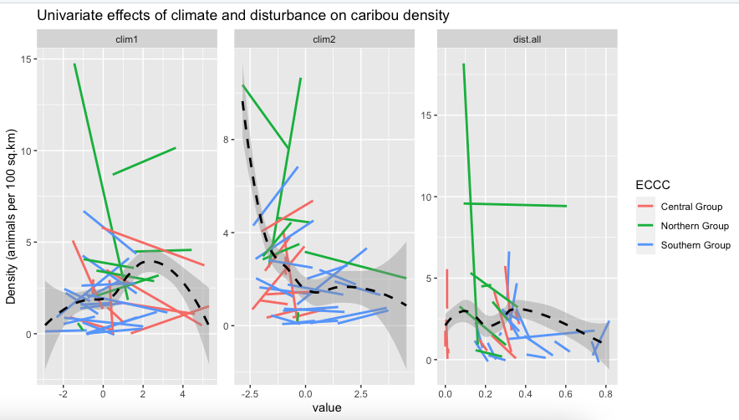

*Figure 4. Linear relationship between annual caribou density (estimated abundance/herd area) and disturbance, climate, and year. No time lags are considered in the disturbance and climate relationships, but they are below.*

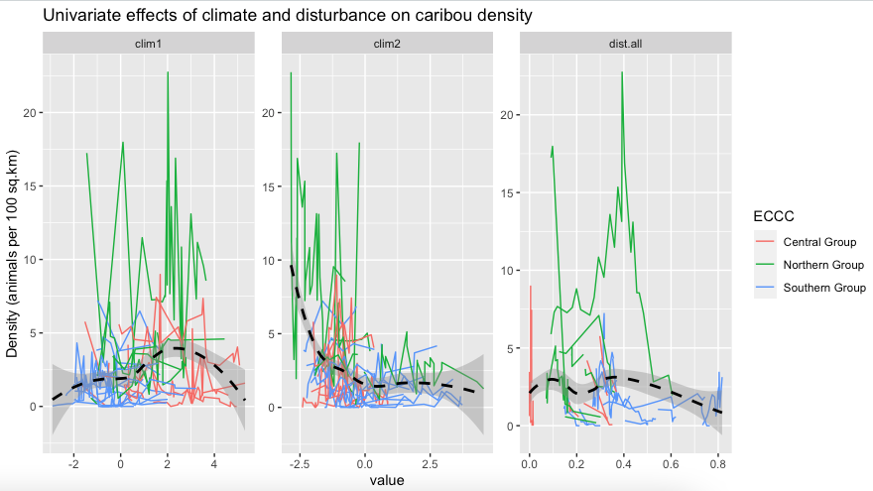

*Figure 5. Raw relationship between annual caribou density (estimated abundance/herd area) and disturbance, climate, and year. No time lags are considered in the disturbance and climate relationships, but they are below.*

*Figure 6. Time lags (top, in years, 0-15) between disturbance and density. By eye, around 10-15 year the slopes begin to line up.*

We fit generalized additive models with various time lags using within herd (random intercept for herd) and across herd (random intercept for year) model structures. A weakness of this approach is that the time lags for disturbance and climate may not be the same. But I can address this in future iterations if it’s a priority.

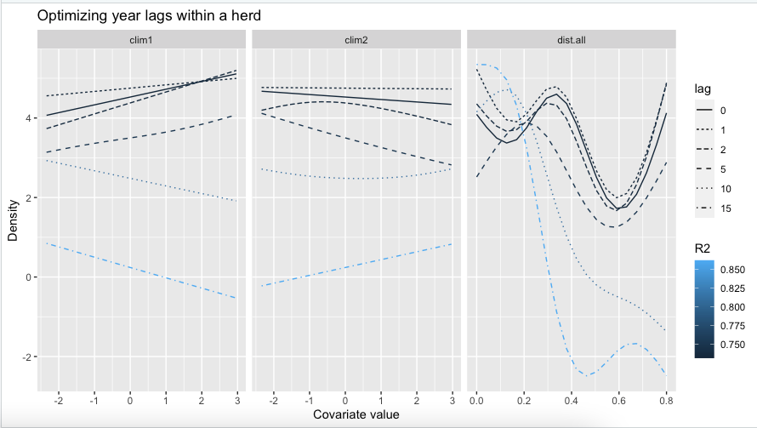

*Figure 7. Generalized additive models considering the multivariate effects of climate and disturbance on caribou density within a herd through time. The top model (by R2) used a 15 year time lag and shows a rapid decline in density beyond ~15% disturbance and a levelling off at very low (or 0) abundance past 40%. Climate variables had only moderate effects.*

*Figure 8. Generalized additive models considering the multivariate effects of climate and disturbance on caribou density across herds. The top model (by R2) used no time lag (0) and shows that the largest herds are in areas of high winter severity (low clim2) and high clim 1 (lower minimum temperatures, larger ranges of temperature variation, and lower vapor pressure). The disturbance effect was small and not consistent across the range of disturbance.*

**Results**

Climate and disturbance regimes were changing within these caribou ranges during the period we considered (1984-2021). However, the only variable that was consistently changing in the same direction within herds was disturbance (Figure 2). There were changes in climate for some herds, sometimes large changes, but overall, these changes were not consistent across herds (although were often similar within groups (i.e., smc, cg, etc)). There was considerable variation in climate and disturbance levels between herds (Figure 3, 3.1).

Exploratory analyses showed that caribou density was much lower in herds with high Clim2 (low winter severity), consistent with the climate hypothesis, but within a herd, increasing Clim2 did not correspond to decreasing density (Figure 4). The relationship between disturbance and density within a herd through time was not consistent or compelling without a lag (lag==0) but when time lags were added a consistent relationship began to appear within herds (Figure 6).

Generalized additive models were used to parse out the multivariate effects of climate and disturbance variables on the within and across herd analyses. Results suggested that a 10-15 year lag was most ideal (based on R2) for the within herd analysis and that increases in disturbance was the primarily predictor of decreases in density. However, looking across herds, those in the least disturbed areas were not necessarily at the highest densities, even after controlling for differing climates. Rather, those with high winter severity (low clim2) and high clim1 (lower minimum temperatures, larger ranges of temperature variation, and lower vapor pressure) were at the highest densities.

**Discussion**

In summary, over the time period considered here disturbance appears to be the primary driver for change within a herd, while low population densities across herds seem to arise due to climate indices. I suspect there is a temporal signature here that we can’t fully account for. It’s possible that climate has had a large and long term effect on caribou well before our data collection began and their populations are thus lower in less favorable climates. The trend of lower population densities due to warmer areas, longer days, and less snow suggests that climate may also play a role in caribou declines in the future seeing as these are the changes we expect to see more of within a herd due to climate change (if we accept a space for time inferences). However, with the data and timeframes we had available, disturbance was a strong predictor of decline within a herd and climate had little effect.

With this preliminary analysis I’m inclined to think that the general paradigm of disturbance-mediated apparent competition holds, and that we are in desperate need of a landscape-level restoration experiment to assess if lowering disturbance can increase a population. Climate may be an overall driver of caribou density across the landscape, and may drive changes in the future, but we did not detect evidence of climate causing major contemporary changes to caribou population size. After controlling for climate effects and differences in density between herds we showed that population declines begin at low levels of disturbance (>10-15%) and by 40% disturbance majority of density has been lost and extirpation may occur.

JW NOTES

* Start from all data are wrong, and all analyses are wrong, then use all the data
* Lambda of the count
* %
* Methods, change in people, etc
* Pine beetle?
* Survival model with herd and year RE
* Re-run IPM